**IDS 410 – Business Database Technology**

**Fall 2022**

**AWS Lab 6**

**Submitted by:**

**Shubham Dwivedi** [**|sdwive4@uic.edu**](mailto:|sdwive4@uic.edu) **| 660328503**

**Review myRedshiftRole**

**create a cluster for your data warehouse**

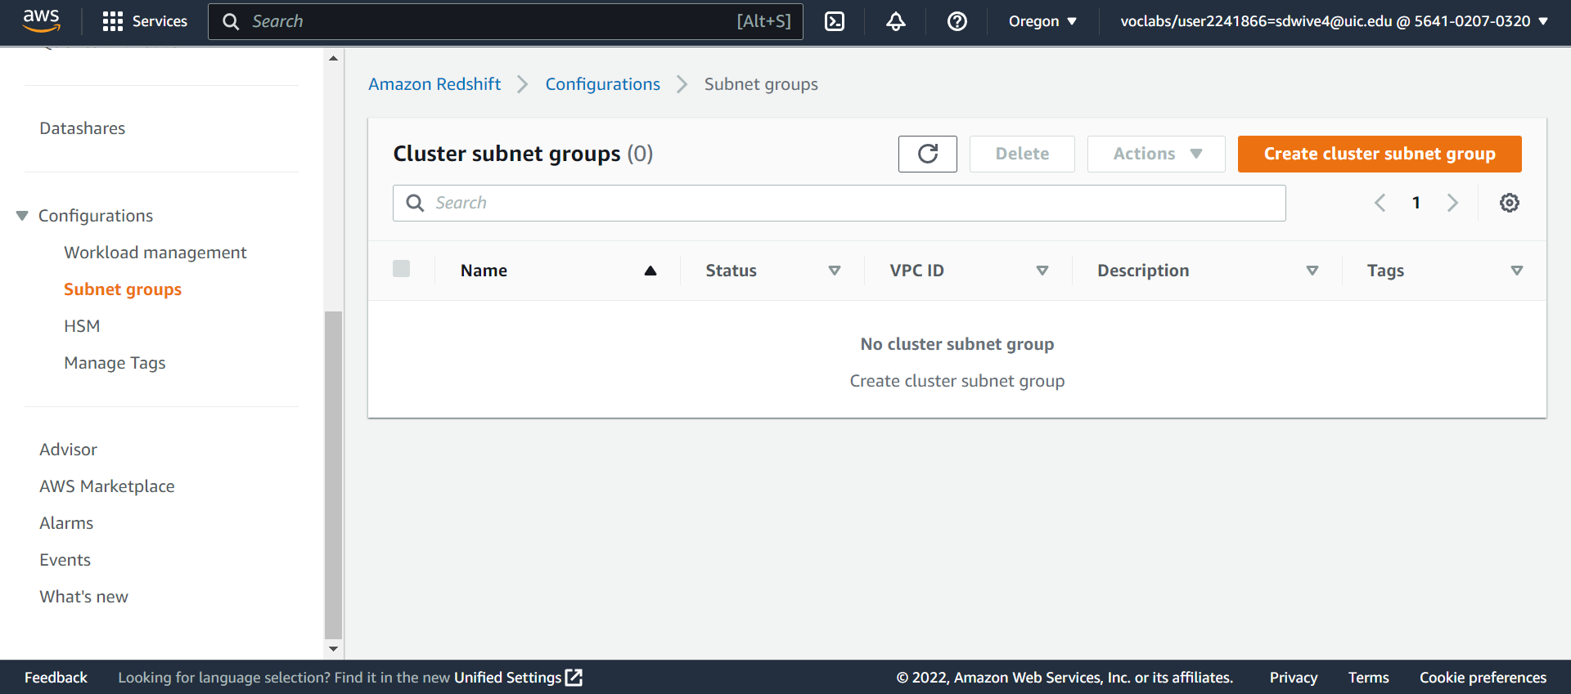

**Create a cluster**

**In the Cluster configuration pane, enter the following values:**

In the **Database configurations** pane, for **Admin user password**, enter Passw0rd1

Choose **Associate IAM role**

In the **Additional configurations** section, turn off **Use defaults**.

For the **Publicly accessible** setting, choose **Enable**.

**Cluster creation I process and created successfully**

**Creating security groups in EC2**

**Adding Properties to Inbound Rules**

**Security Group successfully created**

**Go to Redshift and choose the cluster that you have created. In the properties tab edit the Network and security settings**

Under **VPC security groups**, choose the **Redshift Security Group** that you created.

**Choose the cluster that you created and from the general information copy the JDBC URL.**

**Create a S3 bucket**

**Bucket Created**

**To create a data pipeline. Select Data Pipeline from the All services Menu**

**Add the below details for creating the data pipeline.**

**To monitor pipelines, select the data pipeline created from the List Pipelines**

**To Check Logs, select Activity Logs**

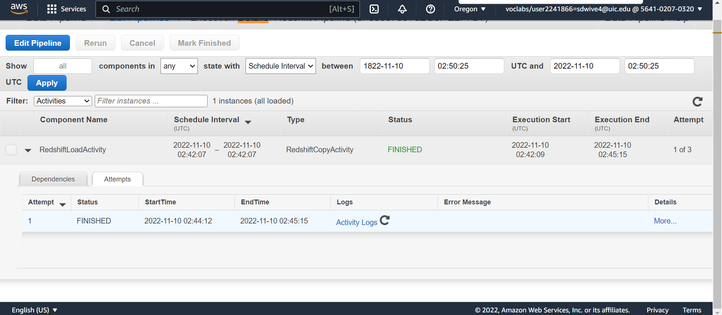

**Log Files**

**Query the Amazon Redshift database**

**On the AWS Management Console, on the Services menu, choose Amazon Redshift. In the navigation pane, choose CLUSTERS**

**From the clusters, open query editor**

**Choose Connect to database and enter the following values: Database name: dev Database user: awsuser**

**From the Select schema dropdown list on the left, choose the public schema. In the Resources pane, choose the jan table. Choose the three dots next to the jan table and choose Preview data.**

**After the query runs, you see the first 10 rows for the January data. You might need to scroll down to see all the data.**

**Challenge Question**

**Create new Pipleline for Feb**

**Create Table SQL Query**

create table feb

(vendorid bigint,

pickup_datetime VARCHAR,

dropoff_datetime VARCHAR,

passenger_count bigint,

trip_distance DOUBLE PRECISION,

ratecodeid bigint,

store_and_fwd_flag VARCHAR,

pulocationid bigint,

dolocationid bigint,

payment_type bigint,

fare_amount DOUBLE PRECISION,

extra DOUBLE PRECISION,

mta_tax DOUBLE PRECISION,

tip_amount DOUBLE PRECISION,

tolls_amount DOUBLE PRECISION,

improvement_surcharge DOUBLE PRECISION,

total_amount DOUBLE PRECISION)

**Below are the screenshots for the Pipeline Creation properties**

Query for most common pickup locations in Redshift

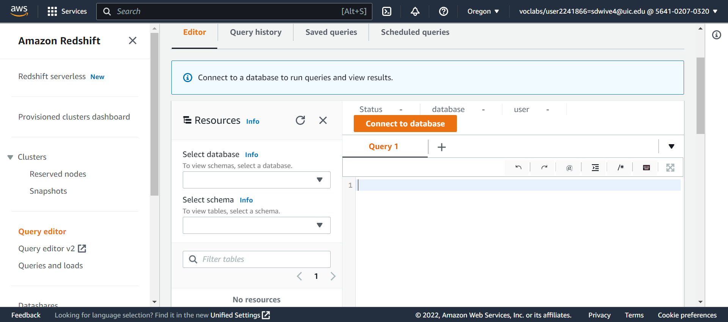

Connect to Database

**Query to find most common pickup locations in January**

SELECT pulocationid

FROM jan

GROUP BY pulocationid

ORDER BY COUNT(*) DESC

LIMIT 1;

**Result: 79**

**Query to find most common pickup locations in February**

SELECT pulocationid

FROM feb

GROUP BY pulocationid

ORDER BY COUNT(*) DESC

LIMIT 1;

**Result: 161**